**Final Project Report**

Edbert Hans 2101684494

Nixon Louis 2101693523

Jordy Filbert 2101693542

In this report we will explain about our final project. All our struggles, how we got the idea to create this project, how long it took us to finish this project, and what we hope to accomplish. At the start of our journey we had no idea what we wanted to create. It was dilemma for us since we did not want to make our project too difficult but not simple as well. We searched for inspiration everywhere from the internet from our friends and even from our TA’s. At first, we wanted to make a phonebook with a GUI we started off well with that idea, but it turns out we had to use C#, but we soon found out that using C# as the language was not allowed and we found out that it wasn’t allowed after three days. With that roadblock we had to change our idea and it took us a couple of days for us to reach our final decision, and in the end, we chose to make a login and register user system. We got this idea from Enrico our TA, he helped us a lot with this project coding wise and advising us. This project would not have been possible without his help. As for how long this took us to create, it took us a couple of days to make this idea into something real. We struggled a lot in how to implement our logic into code. But through our struggles we finally finished our project and we are happy with the finished product. We hope we can turn this simple user system into something more useful and improve ourselves even more.

To start this project off, we have 3 files (2 .cpp and 1 .hpp), those files are

-mainfile.cpp = It’s the main code of the program.

-class.hpp = This file stores the user’s class.

-cons.cpp = This file sets user input to a variable such as username and password.

In the file “class.hpp”, our user class has 2 set, 1 is private and another one Is public. We use private, so the people can’t just change it easily.

In the file “cons.cpp”. this file basically returns what was inserted by the user.

Our project is to make a user storing unit using vector. We can login/register with this program.

This is the explanation of our code:

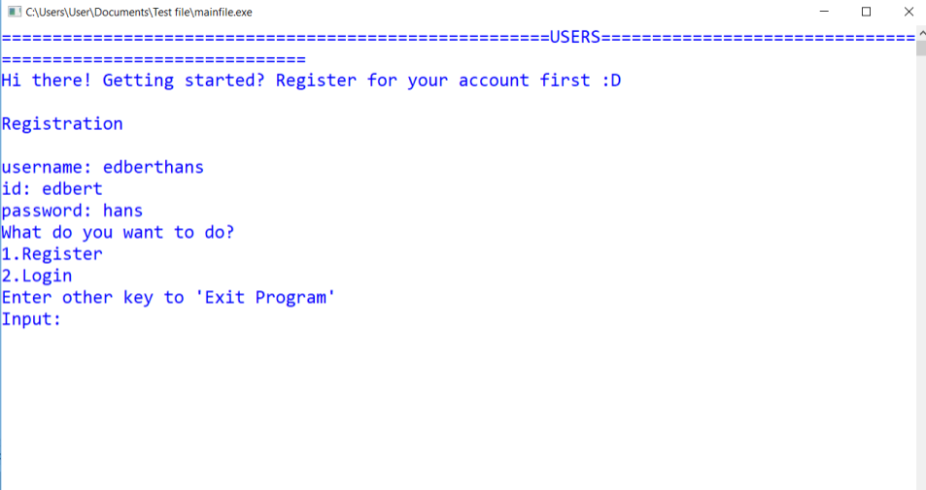

We first register our first account

Then, we are given some option on what we can do.

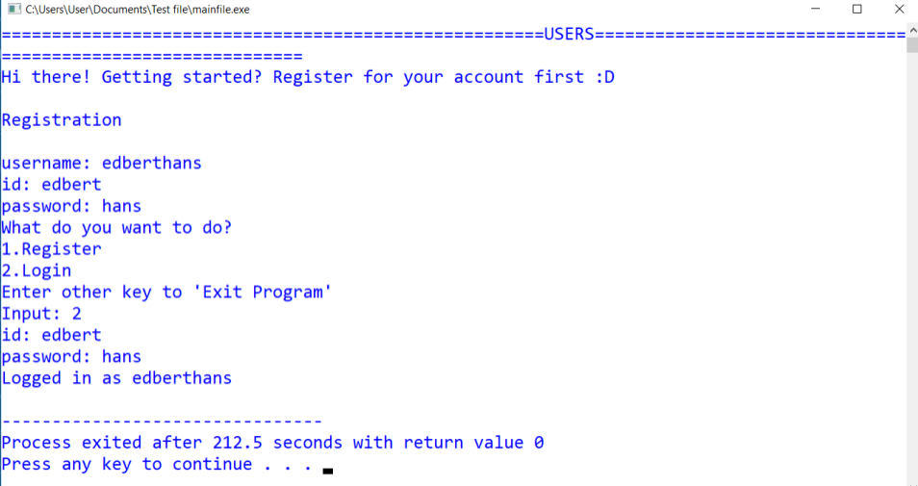

You can instantly login to your account.

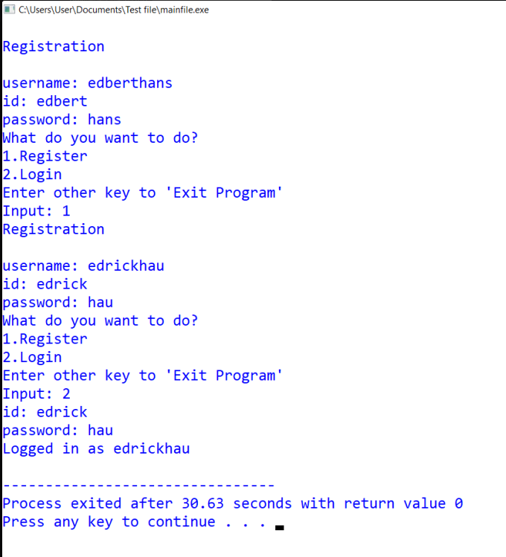

Or, you can register multiple account and login to one of those.

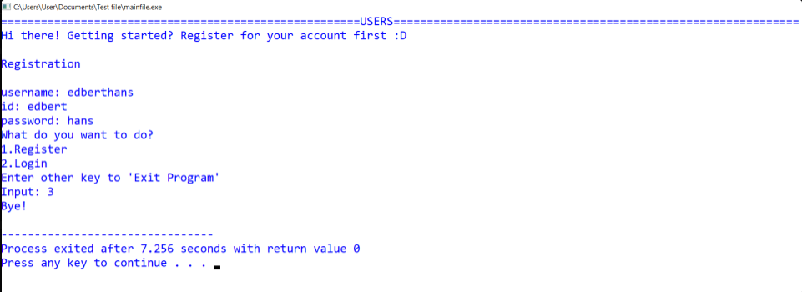

You can also exit the program by entering another key besides 1 and 2.